Wentworth Place
At a Glance

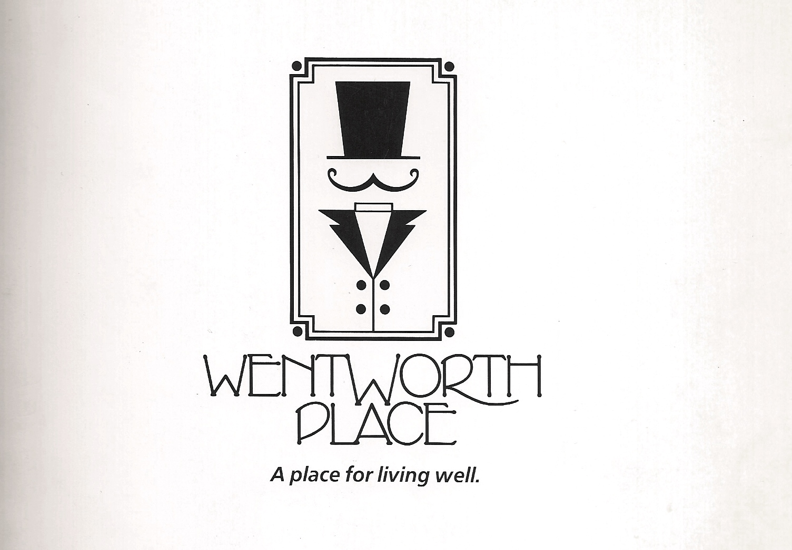

The Board of Directors and the Management Company are pleased to welcome you to Wentworth Place. In this pamphlet, you will find some practical information to help you settle in your new home.

Wentworth Place is conveniently located in the heart of Arlington and within easy walking distance to Ballston Quarter, supermarkets, restaurants, schools, public library, YMCA, various worship facilities, public park, Washington-Liberty pool & track, Northern Virginia Hospital, and excellent public transportation – one block from the Virginia Square metro. This 78-unit community building is 100 percent smoke-free – Smoking is prohibited anywhere on the property.

The Unit Owners Association represents all unit owners and has the responsibility of administering the Condominium, and establishing how it is managed on a day-to-day basis. A Board of Directors is elected at the annual meeting (held in March); subsequent monthly meetings are held during which all matters of the Condominium are addressed (various contracts, upkeep of the property, residents’ forum, etc.). Sensitive matters are discussed during an executive session.

- GHA Community Management LLC is the managing company, and the Portfolio Manager ensures smooth operation of all aspects of the building.
- A Cleaning staff/contractors coordinate all common areas repairs, and handles everyday maintenance.
- The Portfolio Manager is available to address any issues or advise accordingly.

What you need to know:

Bulletin Board: Communications (maintenance matters, Pest control schedule, etc.) concerning the Condominium are posted in the glass cabinets. Residents can post ads, news, on the community board. Both are located in the mail room. Official notices are posted around the building as needed. Residents are not allowed to post personal notices around the building.
Backyard: Alongside the pool, there is a grassy area for residents’ enjoyment. It is very popular for picnics during the summer on a first-come, first-served basis. Residents are responsible for keeping the grounds clean after any gathering. Grills must be identified with name/unit # of owner.
Community room: is available for residents wishing to hold parties, gatherings which cannot be publicly advertised and involve money. Smoking is strictly prohibited; pets are not allowed in the community room. Noise is to be kept to an acceptable level and subject to Arlington Code. A reservation request is required to obtain the key from a representative of the Association, together with a security deposit of $200.00. The policy governing the use of the community room is available on the website under Requests - http://www.wentworthplaceva.com/community-room.html.
Deliveries: Furniture, building materials, moves in/out have to be through the Loading Dock, AND NOT through the Lobby.
Disposing of Christmas Trees: Take the tree out using the stairs and stairwell exit doors and place it in the dumpster. Broom up the path from your unit to the exit. Tree needles should not be left on the carpet or the floor.
Easement of Access to Units: Board directors, Portfolio Manager, and/or the Engineer may enter any unit to the extent necessary in case of an emergency (water/gas leak, burning smell, etc.). Resident will be notified accordingly and informed of any needed repairs.
Elevator Emergency – If you are in an elevator and there’s a malfunction, push the Alarm (Bell) button ONE TIME; the button will light up and an alarm bell will ring. Then push the Telephone button (PUSH TO CALL) ONE TIME ONLY. The Emergency number will be automatically dialed. There will be a brief message and a LONG PAUSE. WAIT and a Dispatcher will come on the line to speak with you. Unless there is a medical emergency, do not call 911 – instead wait for the Elevator Dispatcher to come and open the elevator.
Fire – Call 911; use the stairs NOT the elevators.
Fitness Room: Equipment is available for your workout. Persons using the facility do so at their own risk and responsibility. Equipment must be wiped after use and loose parts placed in the box. For your safety, it is recommended to keep windows/blinds closed after your visit. Smoking is prohibited.
Internet: Comcast, Fios and Starry are available to residents.
Landscape and Snow Removal: Grounds are maintained regularly by a landscaping company; they are also responsible to remove heavy snow and treat ice from the parking lot, driveway, and walkways.
Laundry: Washers and dryers are located on all floors and are card-operated. A machine in the mail room allows you to add value to your card ($5, $10 & $20 bills are accepted or credit card). Additional new cards can be purchased ($10.00 - includes $5.00 credit) if needed. To report a machine malfunction, contact the laundry company; provide the exact machine location and a detailed description of the problem.
Locked out - Please call a locksmith or consider giving a set of keys to a neighbor or friend.
Mail: Each unit has a mail box located outside of the lobby for incoming mail. Outgoing mail can be dropped in the box in the mail room and is collected daily. Packages must be picked up promptly.
Moving in/out: All moves must be through the Loading Dock and NOT through the Front Door or stair exit across from the pool. There’s a non-refundable one-time fee of $450.00 (effective 3/1/2023) for moving in. A security deposit of $200.00 (refundable if no damage done) for moving in AND moving out. Residents must coordinate with the Management Company to obtain the elevator key, and must use only the designated/padded elevator for moving. Moving hours are strictly between 9:00am-5:00pm – Monday through Saturday. No moving allowed on Sundays, holidays AND evenings.
Parking: Each unit is eligible for one parking space; visitor’s parking is on a first-come, first-served basis. Parking tags (1-owner, 1-visitor) are given to each unit owner and cars without a valid tag are towed at owner’s expense is enforced 24/7. Parking in front is limited to one hour at all times. A bicycle rack is located in the backyard.
Pest control: The common areas are treated on a regular basis. However, if you encounter a problem in your unit with ants, roaches or rodents, please contact the Pest control company (see information on Website & in mail room) for prompt treatment. Also, inform the Management Company.
Pets: Residents are allowed one domestic pet per unit (dog/cat weighing no more than 40lbs). Exception has to be requested to the Board of Directors for additional animal. Dogs must be on leash at all times and not walked on green areas. Pets must be kept indoors at all times and registered with the Management Company.
Pool: The pool is officially opened daily from Memorial Day weekend to Labor Day weekend. Schedule and rules are posted at the beginning of the season. Patrons are required to show their pool pass, sign the log-in book and obey the lifeguard’s instructions. Guests must be accompanied by owner/resident.
Storage: Each unit is assigned a storage bin – residents may store items of a non-flammable nature at their own risk. A couple of carts are available for your convenience; please do not keep them in your unit and return them promptly to the storage room. Items left outside of bins will be disposed of. Nothing should be stored in stairwells or left in loading dock.
Trash: Receptacles designated for household trash and recyclables are located on each floor, mail room and loading dock; cardboard boxes must be flattened and taken outside to the dumpster container. Note that appliances, large electronics, toilets/cabinets, construction materials, old carpet, and the like should not be disposed of on the property. You must contact a disposal company to pick up these items. Bulk pickup service is available every other week - schedule posted on Website. Dog poop bags must be disposed only in the bin inside the dumpster enclosure, or designated receptacles.
Security: Access of guests or delivery personnel/contractors is through the callbox. For your safety, please DO NOT allow anybody to enter the building behind you. Contact the Management company to have your telephone number programmed. Entry is through electronic FOB and additional devices can be requested by contacting the Management Company.
Web Address: WentworthPlaceVA.com.
General: All persons will be properly attired when appearing in common areas, halls, and other public places of the property. The volume of radio/television/musical instruments will be kept to acceptable level at all times. Despite reduced volume, residents will ensure that such sound producing devices as well as any hammering/repair work do not disturb neighbors between the hours of 9:00pm and 7:00am on weekdays and 9:00pm and 10:00am on Saturdays/Sundays & holidays. Apartments flooring must be covered with carpeting (80 percent of the areas), except bathrooms & kitchen.
CONTACTS

Emergency (Police/Fire, etc): 911

Police: Non-emergency: 703-558-2222

Washington Gas: 703-750-1400

Animal Control (Arlington county): 703-931-9241; 703-228-6525

Management Company:
GHA Community Management LLC
Prosperity Plaza, 3020 Hamaker Court, Suite 300
Fairfax, VA 22031-2220
Tel: 703-752-8300; Fax: 703-876-9594
Email: AGreene@ghacm.com

GHA Emergency #: 1-888-660-7132

Laundry Services:
Scheffres Laundry Service - www.scheffreslaundry.com
Tel: 301-565-4940; email: service@scheffreslaundry.com

Pest Control:
Owl Pest Prevention - tel: 1-800-229-1056; 301-773-0400
Fax: 301-386-4455; email: service@owlpest.com
(Schedule of visits and reservations posted in Mail Room and under Notices on the website)

Towing Company:
Advance Towing Company, LLC – Tel: 703-525-0550

Board of Directors (elected in March 2024)
President: Linn Deavers
Vice-President: Donald Reinecker
Treasurer: Charles Wright
Secretary: Christiane Eliopoulos
Members: Justin Baker
Joyce Stadnick

