Asphalt project / paving of some parking lot areas and front driveway
Wednesday June 9, 2021
RESIDENTS MUST REMOVE THEIR CARS FROM THE MARKED AREAS BY 9:00AM ON JUNE 9.
VEHICLES NOT REMOVED WILL BE TOWED AND RELOCATED AT OWNER'S EXPENSE
Thank you for your understanding and cooperation.
Management

Driveway to beyond dumpster Row by fence up to visitors' spaces
and row across garages Row by pool and around pool corner

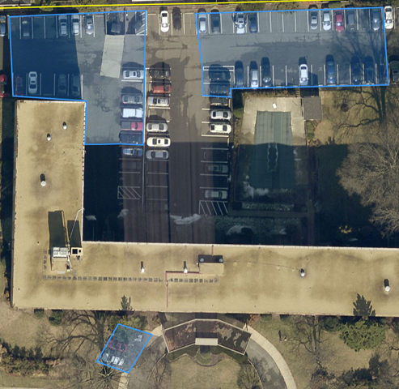
Parking spaces IN FRONT driveway.

